***COMPUTER VISION***

Sarjitha P S

NSTI W TRIVANDRUM

**1. Image Resizing, Cropping, and Rotation**

**# Load the necessary library**

**import cv2**

**import matplotlib.pyplot as plt**

**# Load an image**

**image = cv2.imread('3.jpg')**

**# Convert the image from BGR (OpenCV format) to RGB (Matplotlib format)**

**image_rgb = cv2.cvtColor(image, cv2.COLOR_BGR2RGB)**

**# Resize image to 256x256 pixels**

**resized_image = cv2.resize(image_rgb, (125, 128))**

**# Display the original and resized images**

**plt.figure(figsize=(10, 5))**

**plt.subplot(1, 2, 1)**

**plt.title('Original Image')**

**plt.imshow(image_rgb)**

**plt.axis('off')**

**plt.subplot(1, 2, 2)**

**plt.title('Resized Image (125x128)')**

**plt.imshow(resized_image)**

**plt.axis('off')**

**plt.show()**

**# Save or display the resized image**

**# cv2.imwrite('resized_image.jpg', resized_image)**

**# Crop image to a region (x, y, width, height)**

**cropped_image = image_rgb[50:130, 50:200]**

**# Display the original and resized images**

**plt.figure(figsize=(10, 5))**

**plt.subplot(1, 2, 1)**

**plt.title('Original Image')**

**plt.imshow(image_rgb)**

**plt.axis('off')**

**plt.subplot(1, 2, 2)**

**plt.title('cropped_image')**

**plt.imshow(cropped_image)**

**plt.axis('off')**

**plt.show()**

**# Rotate image by 45 degrees**

**(h, w) = image_rgb.shape[:2]**

**center = (w // 2, h // 2)**

**M = cv2.getRotationMatrix2D(center, 45, 1.0)**

**rotated_image = cv2.warpAffine(image_rgb, M, (w, h))**

**# Display the original and resized images**

**plt.figure(figsize=(10, 5))**

**plt.subplot(1, 2, 1)**

**plt.title('Original Image')**

**plt.imshow(image_rgb)**

**plt.axis('off')**

**plt.subplot(1, 2, 2)**

**plt.title('rotated_image')**

**plt.imshow(rotated_image)**

**plt.axis('off')**

**plt.show()**

**OUTPUT:-**

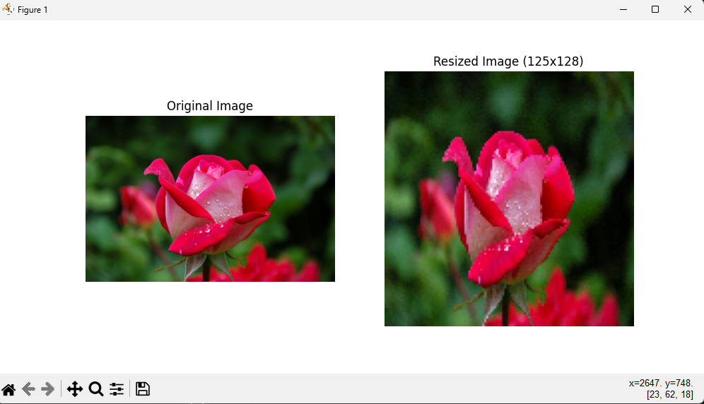

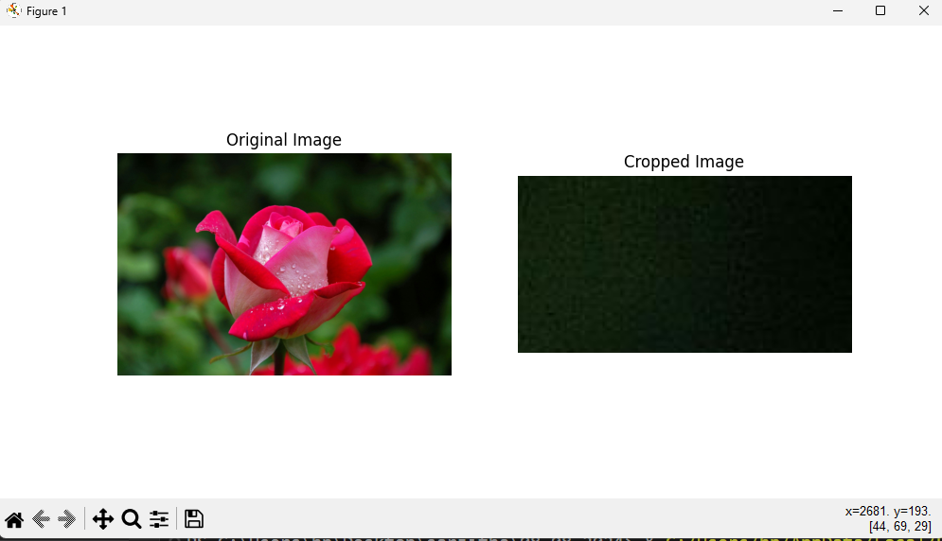

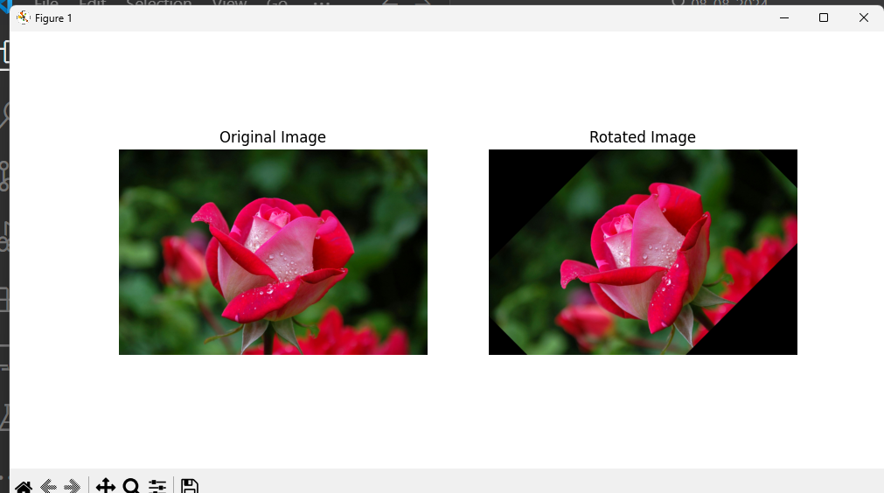

**2. Loading_Image_Formats_Tutorial**

**import cv2**

**import matplotlib.pyplot as plt**

**# Load an image using OpenCV**

**image_path = "3.jpg"**

**image_cv2 = cv2.imread(image_path)**

**# Convert the image from BGR to RGB**

**image_cv2_rgb = cv2.cvtColor(image_cv2, cv2.COLOR_BGR2RGB)**

**# Display the image**

**plt.imshow(image_cv2)**

**plt.title('Image loaded with OpenCV')**

**plt.show()**

**from PIL import Image**

**# Load an image using PIL**

**image_pil = Image.open(image_path)**

**# Display the image**

**plt.imshow(image_pil)**

**plt.title('Image loaded with PIL')**

**plt.show()**

**import imageio**

**# Load an image using imageio**

**image_imageio = imageio.imread(image_path)**

**# Display the image**

**plt.imshow(image_imageio)**

**plt.title('Image loaded with imageio')**

**plt.show()**

**# PNG image path**

**image_path_png = "4.png"**

**image_path_jpg = "2.jpg"**

**# OpenCV**

**image_cv2_png = cv2.imread(image_path_png)**

**image_cv2_png_rgb = cv2.cvtColor(image_cv2_png, cv2.COLOR_BGR2RGB)**

**plt.imshow(image_cv2_png_rgb)**

**plt.title('PNG loaded with OpenCV')**

**plt.show()**

**# PIL**

**image_pil_png = Image.open(image_path_png)**

**plt.imshow(image_cv2_png_rgb)**

**plt.title('PNG loaded with OpenCV')**

**plt.show()**

**# imageio**

**image_imageio_png = imageio.imread(image_path_png)**

**plt.imshow(image_cv2_png_rgb)**

**plt.title('PNG loaded with OpenCV')**

**plt.show()**

**OUTPUT:-**

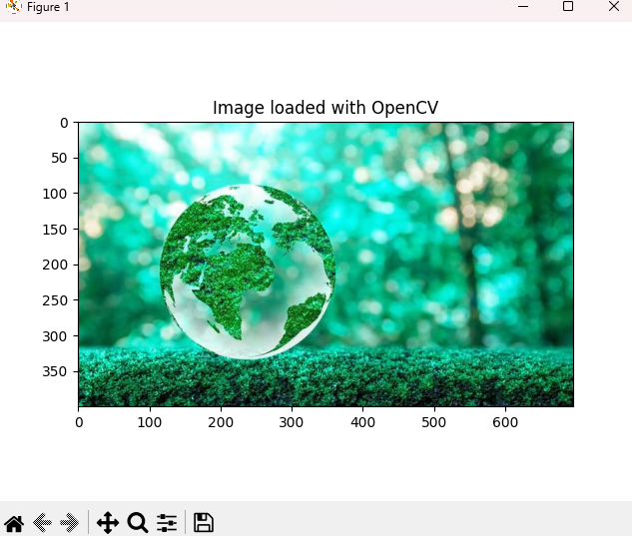

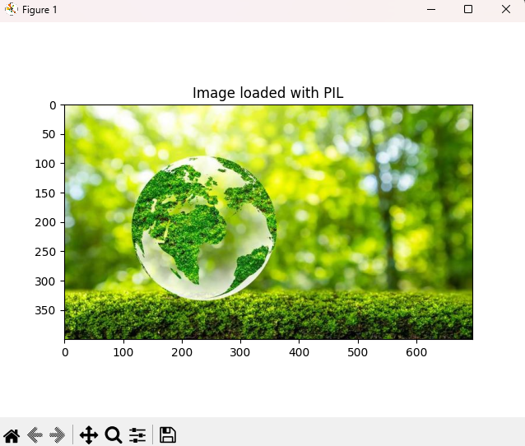

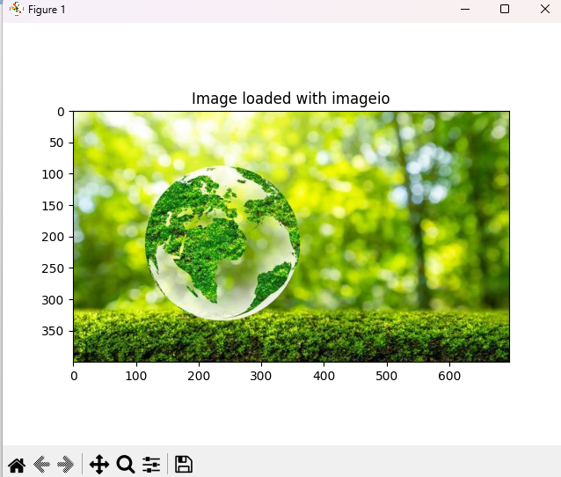

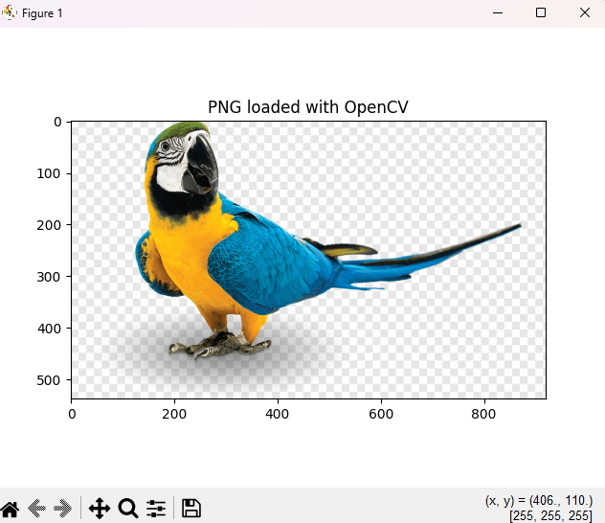

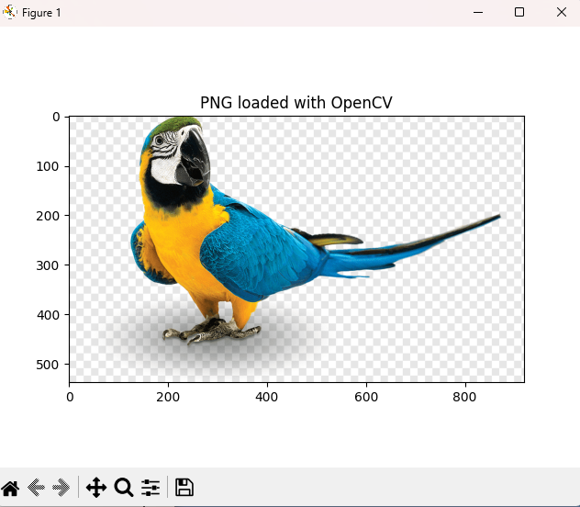

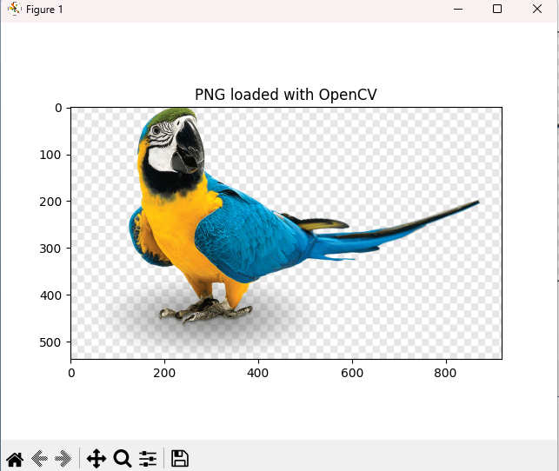

**3. Image Denoising**

**# import necessary libraries**

**import cv2**

**import matplotlib.pyplot as plt**

**# Load an image**

**image = cv2.imread('1.jpg')**

**# Convert the image from BGR (OpenCV format) to RGB (Matplotlib format)**

**image_rgb = cv2.cvtColor(image, cv2.COLOR_BGR2RGB)**

**# Apply Gaussian blur to denoise**

**denoised_image = cv2.GaussianBlur(image_rgb, (11, 11), 0)**

**# Display the original and resized images**

**plt.figure(figsize=(10, 5))**

**plt.subplot(1, 2, 1)**

**plt.title('Original Image')**

**plt.imshow(image_rgb)**

**plt.axis('off')**

**plt.subplot(1, 2, 2)**

**plt.title('denoised_image')**

**plt.imshow(denoised_image)**

**plt.axis('off')**

**plt.show()**

**# Convert to grayscale**

**gray_image = cv2.cvtColor(image_rgb, cv2.COLOR_BGR2GRAY)**

**# Apply histogram equalization**

**equalized_image = cv2.equalizeHist(gray_image)**

**# Display the original and resized images**

**plt.figure(figsize=(10, 5))**

**plt.subplot(1, 2, 1)**

**plt.title('Gray Image')**

**plt.imshow(gray_image, cmap="gray")**

**plt.axis('off')**

**plt.subplot(1, 2, 2)**

**plt.title('equalized_image')**

**plt.imshow(equalized_image, cmap="gray")**

**plt.axis('off')**

**plt.show()**

**OUTPUT:-**

